On Gold

Gold is an internation asset. It is priced in multiple exchanges around the world with standarized purity, contracts, etc. China and India compete for the top spot in overall gold consumption. However, India is the largest consumer of gold for jewelry. However, in the eyes of the average household, jewelry is not treated as a consumption good but an investment asset.

There are mulitple reasons to invest in gold.

Currency Devaluation

The Indian Rupee has been a one-way bet.
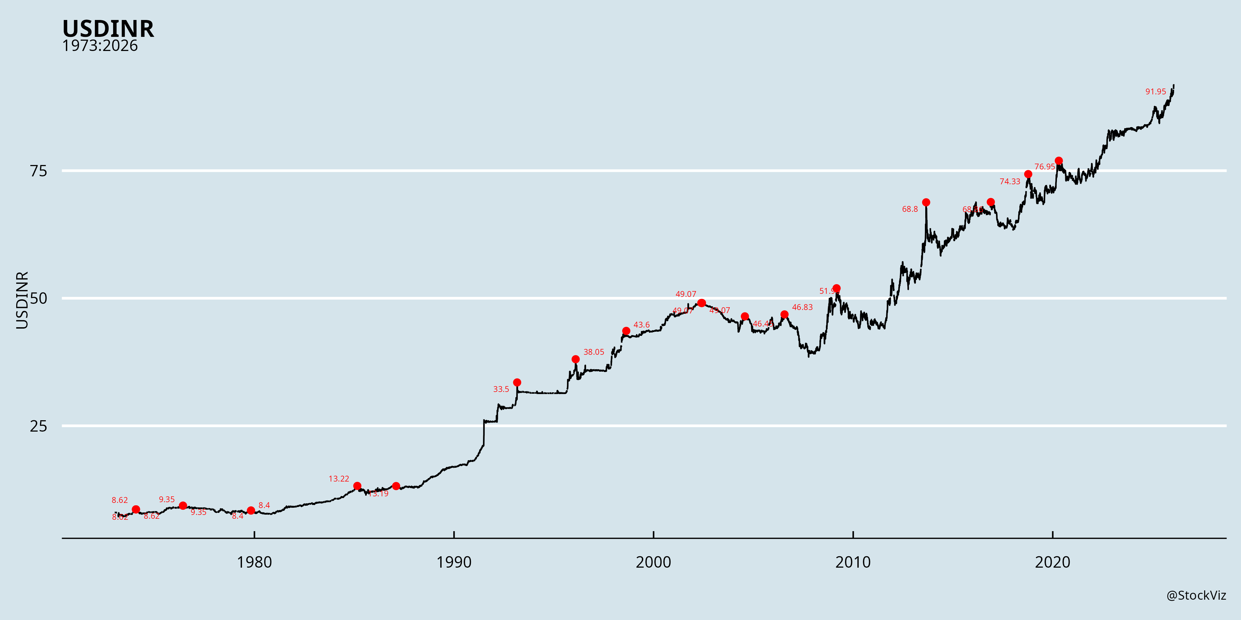

From single-digits in the 80’s to almost triple-digits now, stuffing rupees under the mattress has never been a good idea.

The Indian Rupee devalues because we have always managed a trade deficit (we simply do not export much.) And occasionally, capital flees the country on reduced risk-appetite but the currency never seems to recover from the shock.

Gold, priced internationally, automatically retains its purchasing power.

Inflation
India has had its fair share of inflation shocks. While equities provide some shelter against it, it is not highly correlated.
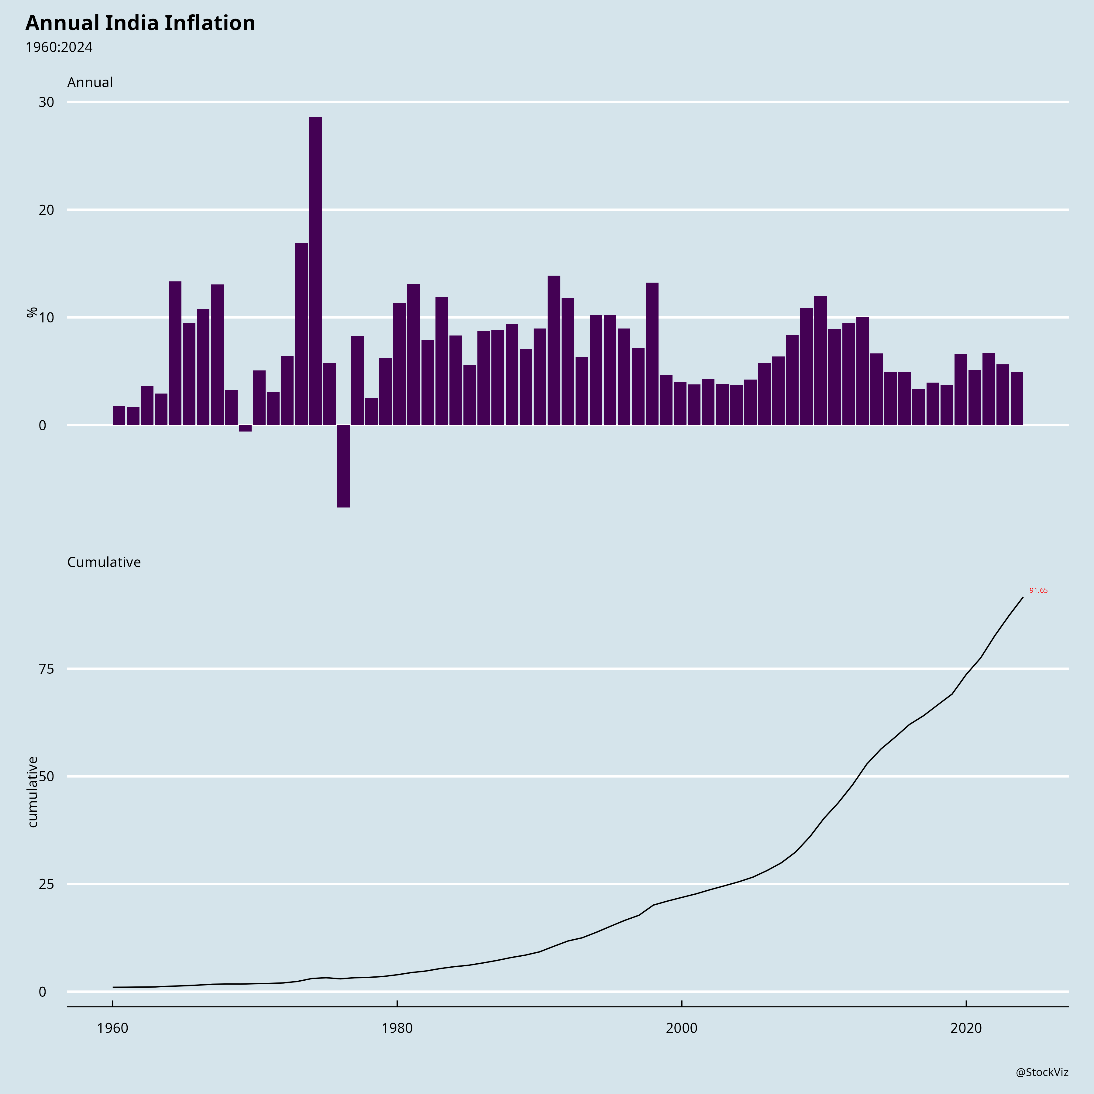
With inflation eating away at saving, it maybe tempting to turn to gold. However, there is no correlation between returns on gold and inflation in India.
The effect could be indirect: a currency shock causes inflation and results in the price of gold going up in rupees.

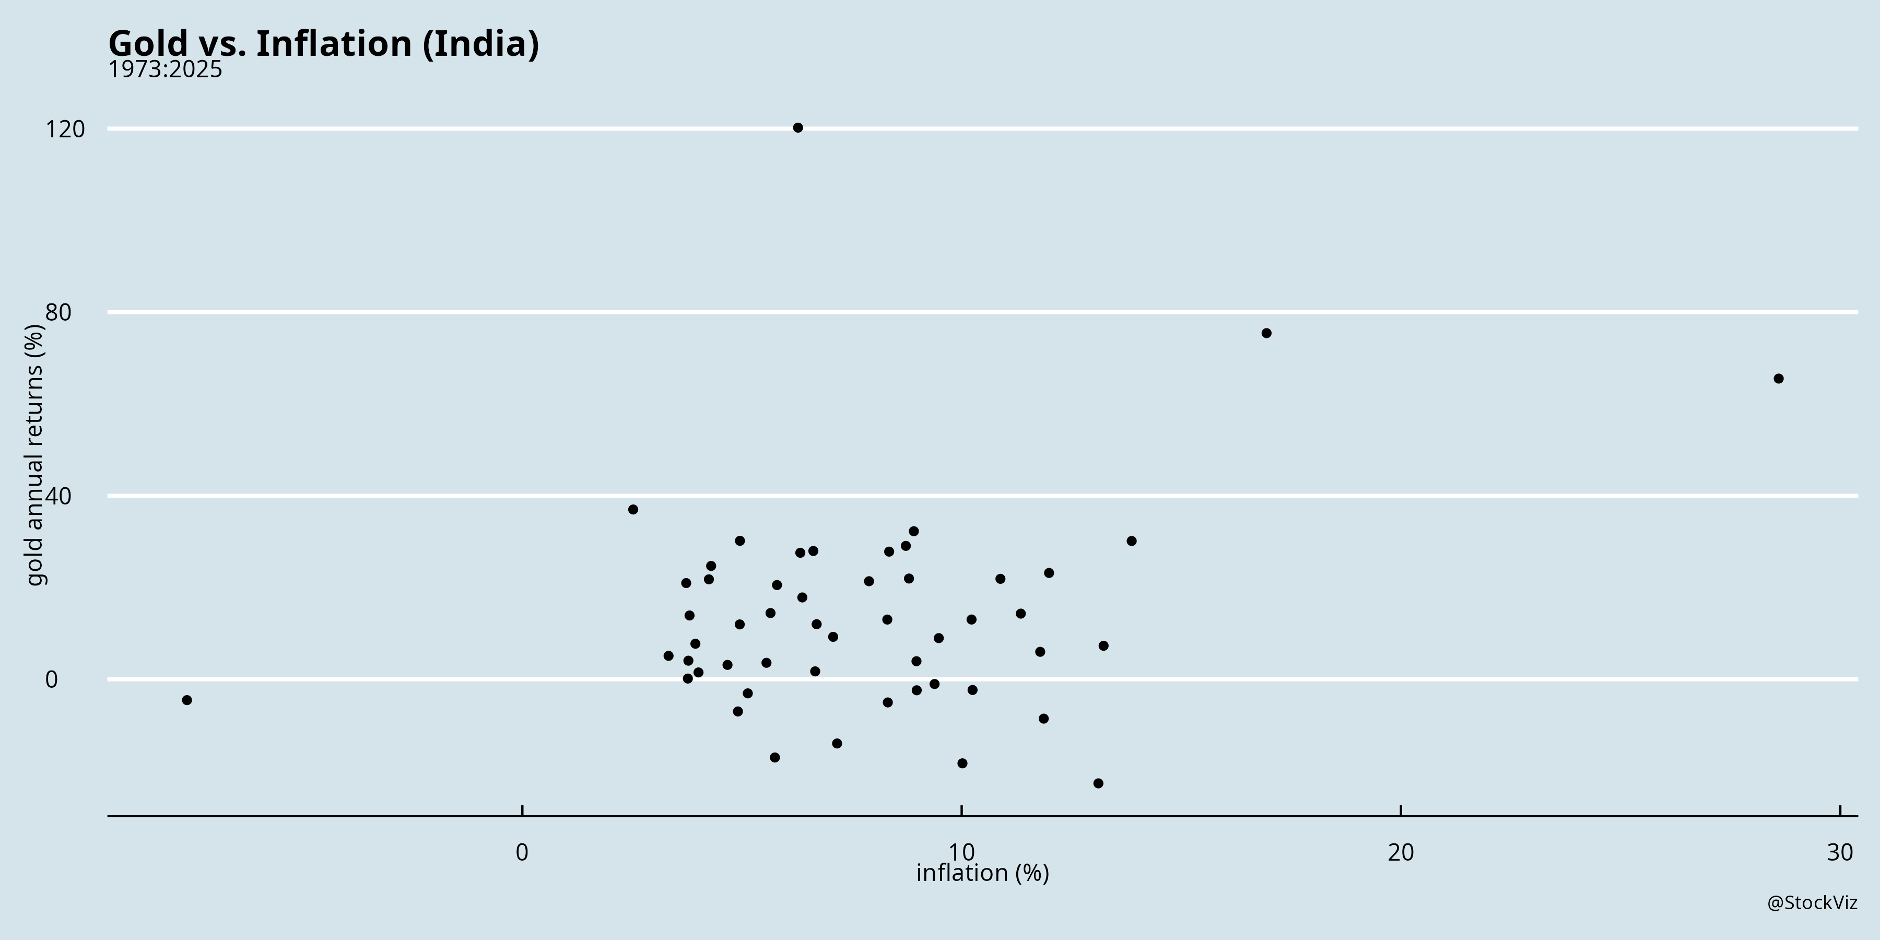

Diversification
Equities only partially offset the loss of buying power due to inflation/depreciation. Given the inherent volatility of equities, it makes sense to diversify into uncorrelated assets. And gold fills the gap.
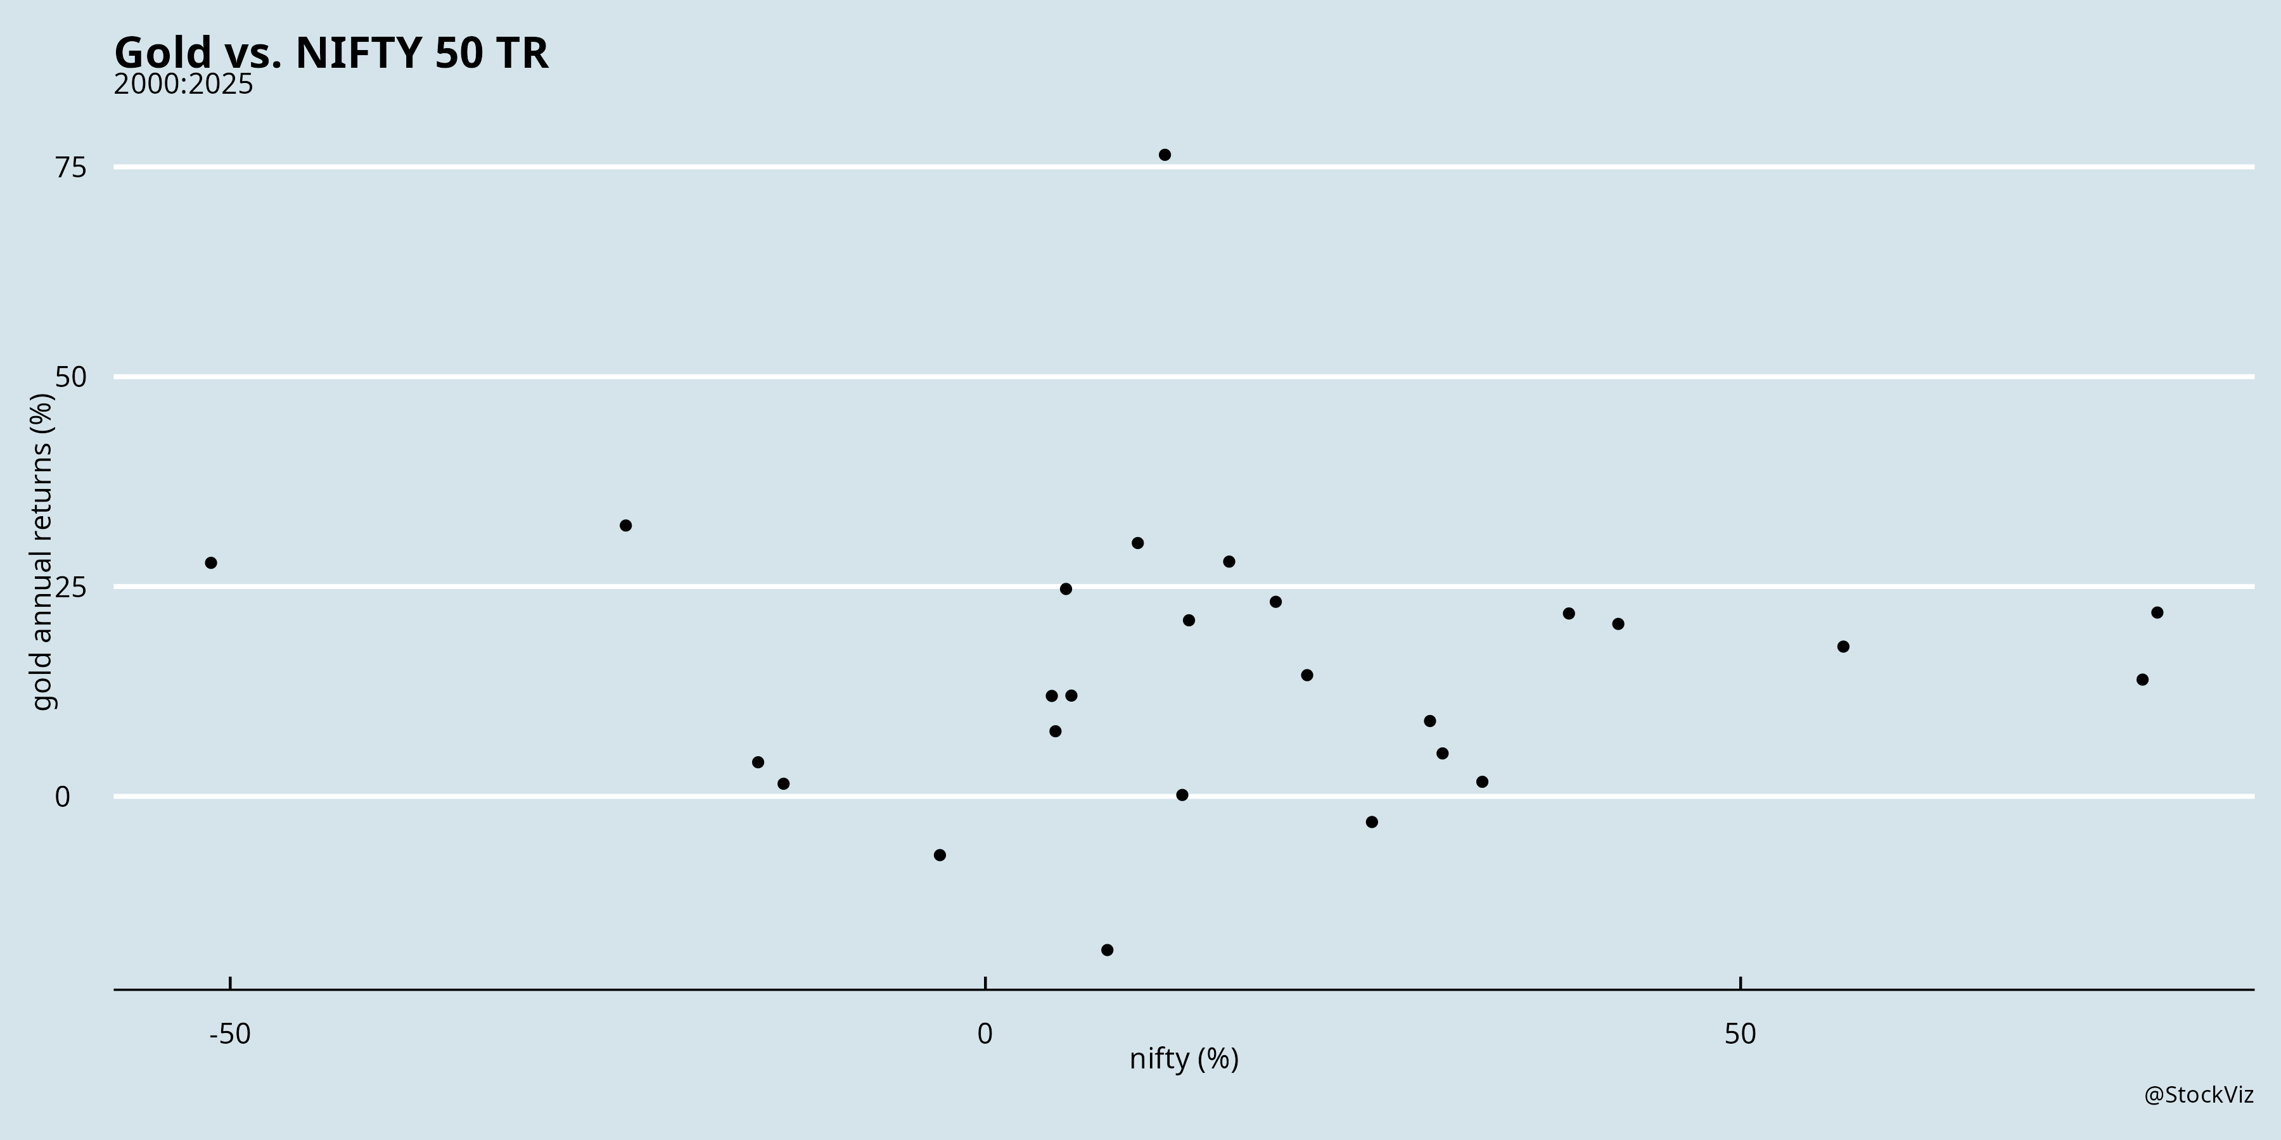
There’s not much of a correlation between annual NIFTY 50 (TR) returns and Gold returns. Combining the two makes sense.

Since the year 2000, Gold has beaten NIFTY 50 – 14.14% vs. 13.21% CAGR – with a higher Sharpe Ratio as well. And the best part: both beat inflation which pencils out to 6%.

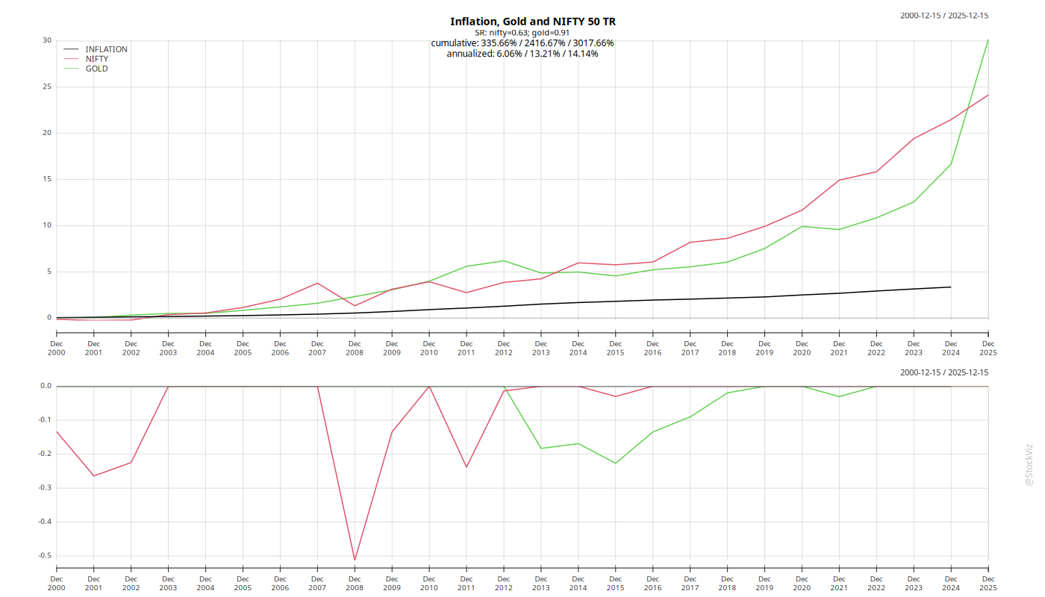
The cumulative returns hide the fact that over any 3- or 5-year period, you will look a fool for having chosen one asset over the other. A steady SIP/DCA into a basket of equities and gold makes a ton of sense.

